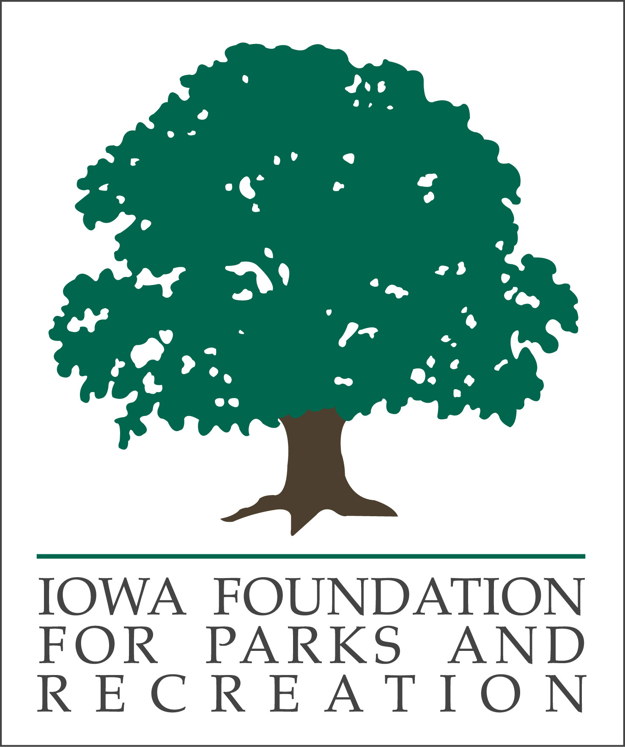

NRPA Conference Professional Fellowship
2023 Fellowship Application Form
(Fellowship value up to $2000)

A. To be completed by applicant (please type or print legibly):

Name _______________________________________ Title ______________________________

Department ____________________________

Work Address ___________________________________________________________________
Street address City Zip
Phone Number _________________________ Email _____________________________

Member of IPRA ______ Yes _______ No Years as IPRA Member ______________

Member of NRPA ______ Yes _______ No Years as NRPA Member ______________

Years of Experience as a Full-time Professional _____________________

Direct Supervisor Name Supervisor Title _____________________

Please attach:
- One-page letter of support from your supervisor
- On a separate page discuss the following (one-page total please):
  - Why you are applying for this fellowship.
  - How attending the NRPA Conference will benefit you and/or agency.
  - Describe previous and/or current IPRA and/or IFPR involvement (e.g. Leadership Institute, conference, workshop, young professional forum, committee work, etc.)

Criteria used to select recipient:
- Completion of application form, supervisor support letter, and one page essay.
- Experience serving as a member of IPRA.
- Candidate that demonstrates the most need for the fellowship and would best represent IPRA and IFPR at NRPA Conference.

Submitted by Date

Deadline: Noon, Friday, August 18, 2023
Please complete and return to:
Geoff Hubbard
Marshalltown Parks & Recreation Director
ghubbard@marshalltown-ia.gov

** Application materials to be electronically submitted **

THANKS TO OUR SPONSORS WHO HELP MAKE THIS SCHOLARSHIP POSSIBLE:
ACCO LIMITED, JEO, MCCLURE, MUSCO SPORTS LIGHTING LLC, MSA PROFESSIONAL SERVICES, SHADE CREATIONS

