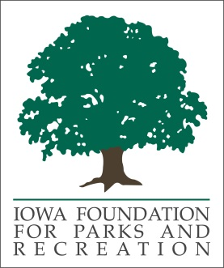
Board Member Application
Application deadline – March 1, 2023

Name______________________________________________ Title_________________________________________
Address___________________________________________________________________________________________
Agency_____________________________________________ Phone_______________________________________

Give a brief history of yourself and/or your organization and background in parks, recreation, or community wellness. __________________________________________________________________________________________________
__________________________________________________________________________________________________
__________________________________________________________________________________________________
__________________________________________________________________________________________________
__________________________________________________________________________________________________
__________________________________________________________________________________________________
Why are you interested in serving on the Foundation Board? ________________________________________________
__________________________________________________________________________________________________
__________________________________________________________________________________________________
__________________________________________________________________________________________________

Do the requirements of serving on the Board and the time commitment present any problem for you?
No __________ Yes __________

What qualities do you possess that would make you an asset to the Foundation _________________________________
__________________________________________________________________________________________________
__________________________________________________________________________________________________
__________________________________________________________________________________________________
Send application to:
Danae Edwards
dedwards@Waukee.org

