Criteria for NRPA National Conference Professional Fellowship
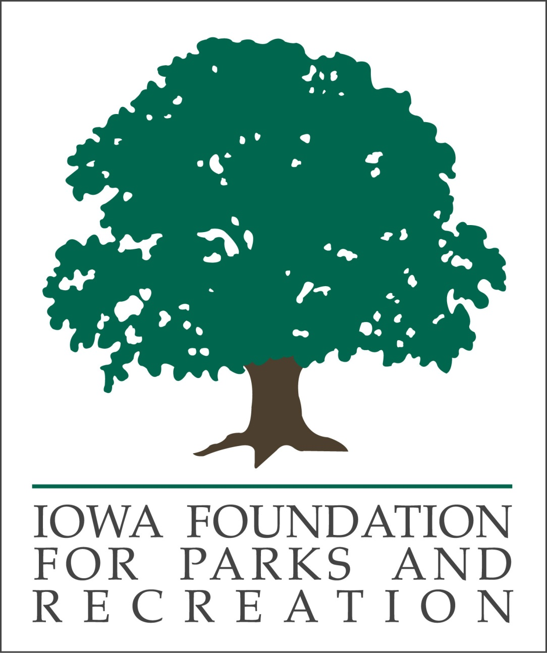

2022 National Conference: Phoenix, Arizona
September 20-22 (Tuesday-Thursday)
IFPR is proud to offer this professional development growth experience opportunity. Our vision is to build a better Iowa through parks and recreation. The recipient’s conference experience will support that vision of creating a stronger department which can elevate community quality of life for years. Gaining career knowledge via nationally recognized speakers, interacting with out of state colleagues, in addition, engaging hundreds of potential business contacts at the exhibit hall are more reasons to apply.

Grant covers, up to $2000:
- Airfare or travel
- Hotel accommodations (up to four nights)
- Full delegate package
- Limited meals

Criteria:
- Current IPRA professional member.
- Minimum of at least two years professional membership with IPRA.
- Currently employed in parks and recreation with two or more years of experience in the field.
- Has not previously attended the NRPA Conference or has not attended for a minimum of seven years. Priority will be given to applicants who have never attended Conference. After that initial ranking, applicants will be put in descending order from the last time they attended (i.e. 7, 6, 5, 4, 3, 2 years).
- Priority will be given to those applicants who have been active within IPRA and/or IFPR. Such as, supports the current or past efforts of IPRA and/or IFPR by serving on a committee, has volunteered at IPRA events, and/or served on the board of directors of either organization.
- Attendance at past IPRA Conferences and/or Fall Workshops.
- Quality of essay and quality of supervisor support letter.

Program/Fellowship Requirements:
- Submit required application and supplemental materials (refer to Application Requirements)
by noon, Friday, August 19, 2022.
- Recipient will be asked to turn in IPRA CEU forms to show they attended sessions.
- Recipient will be asked to write a brief article for the IPRA magazine highlighting their experience due within 30 days of returning from Conference.
- Recipient will be assigned a mentor to interact with during the NRPA Conference (current IPRA president or president designee).
- Recipient may be asked to attend selected NRPA governance meetings.

Application Requirements:
- Completed application. All materials to be electronically submitted as one (1) attachment.
- A one-page typed sheet of paper explaining why the applicant is applying for the fellowship, how it would benefit the applicant and/or applicant’s agency, and articulate previous and/or current IPRA and/or IFPR involvement.
- One letter of support from the applicant’s supervisor.
- Questions and applications are to be directed to Geoff Hubbard, Marshalltown Parks & Recreation, ghubbard@marshalltown-ia.gov or 641-754-5715 x4.

Selection:
- All applications will be reviewed by three (3) members from the IFPR Board of Directors.
- The fellowship will be awarded to the candidate that demonstrates the most need for it and would best represent IPRA and IFPR at NRPA Conference.
- Recipient and non-recipients will be notified no later than August 25, 2022.
This Fellowship is a special project funded by the Iowa Foundation for Parks and Recreation.

