ICPRD’S ICE COVID-19 RE-OPENING PLAN
FAQs

IS THE HOT TUB OPEN?
NO. Due to the size, the spa will be closed until physical distancing guidelines are lifted.

WHAT IS THE COST?
ICE will be charged $4 per lane.

HOW MANY LANES ARE AVAILABLE?
ICE can rent 2 lanes per hour or 3-time blocks with 4 lane reservations. The 4 lane time block cannot be used from 7:15-8:15 AND 3:45-4:45p but it can be used for 1 and then 2 for the other due to these high volume times.

WHEN ARE RESERVATIONS DUE?
ICE must report what times and how many lanes they’d like by the by Thursday, June 4th for the week of June 15-19.

ARE THE LOCKER ROOMS OPEN?
YES. The men’s, women’s A and B, assisted locker room, and both on deck locker rooms are open and able to be used by the public. Patrons are expected to conduct themselves in accordance with local health and safety practices such as mask use, maintaining a minimum of 6-feet between themselves and others, and consciously minimizing touchpoints on shared surfaces. We encourage individuals to arrive ready to swim and to only use the facilities that they need to.

IS EQUIPMENT AVAILABLE TO USE? (KICKBOARDS, BARBELLS, NOODLES, ETC)
NO. ICPRD equipment will not be available for public use at this time. Swimmers are welcome to bring their own equipment, but will be required to sanitize it thoroughly prior to entering the pool deck. ICE athletes should bring their own equipment
WHERE CAN ICE PRACTICE DRYLAND?
ICE can utilize the solarium for dryland exercise under direction of a coach and with social distancing measures in place. ICPRD can assist in laying out semi-permanent grids for social distancing if ICE wishes.
PUBLIC SWIM HOURS
Mid-section only, 8 lanes
MORNING | A BLOCK  7:15am to 8:15am
DECK SANITATION
8:15am to 8:30am
B BLOCK
8:30am to 9:30am
DECK SANITATION
9:30am TO 9:45am
C BLOCK
9:45am to 10:45am
SHIFT CHANGE & DECK SANITATION
11:00am to 12:00pm
AFTERNOON | D BLOCK  12:00pm to 1:00pm
DECK SANITATION
1:00pm to 1:15pm
E BLOCK
1:15pm to 2:15pm
DECK SANITATION
2:15pm to 2:30pm
F BLOCK
2:30pm to 3:30pm
DECK SANITATION
3:30pm to 3:45pm
G BLOCK
3:45pm to 4:45pm
POST-SHIFT SANITATION
5:00pm to 6:00pm
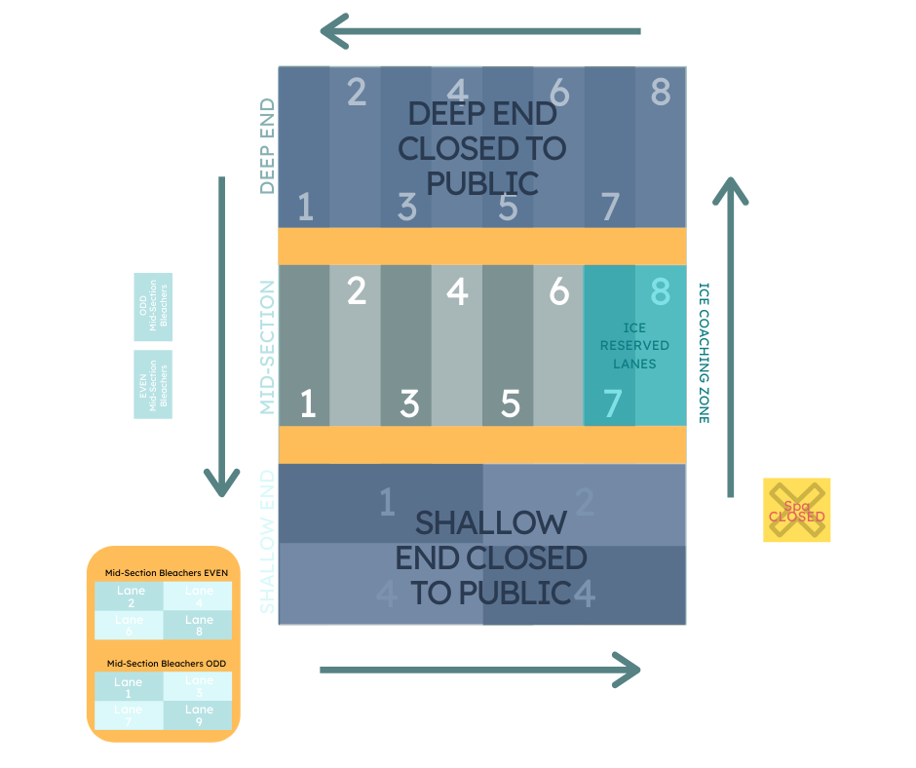
SCREENING PROTOCOLS

WHEN THE SWIMMER/COACH ARRIVES FOR THEIR SCHEDULED SWIM TIME...
Check their name and the schedule to confirm that they are on the schedule for the correlating time slot. Once you’ve confirmed their reservation:
- Take the swimmers temperature
- Run through screening questions
- Explain new policies in place
- Send into locker room

If the swimmer is running a temperature, has left the state within the last 14-days, has any symptoms of COVID-19, or has come in contact with a confirmed or suspected but untested case of COVID-19, they should be turned away and asked not to return for 14-days or until symptoms subside.

